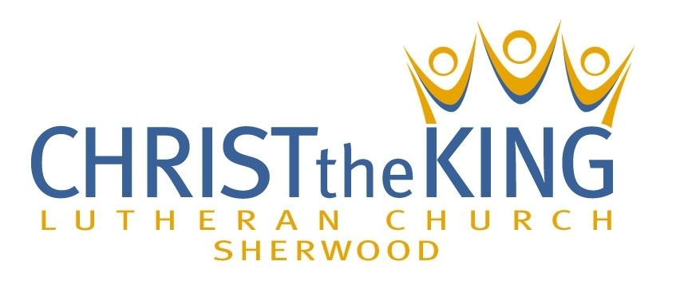

2023 Annual Report
to the
Congregation

February 25, 2024

Table of Contents

Annual Congregational Meeting Agenda – pg. 3

Message from Bishop Elizabeth Eaton, Presiding Bishop, ELCA – pg. 4

Statistical Report for 2023 – pg. 5

Letter from the Council President – pg. 6

Church Committee Updates – pgs. 7-8

Commit. Minutes of Last Year’s Annual Congregational Meeting, held 2/26/23 – pg. 9

Minutes of This Year’s Financial Meeting, held 12/10/23 – pgs. 10-11

Financial Statements of Income, Expense & Cash Balance for year ending 12/31/23 – pg. 12

Mortgage Report for the year ending 12/31/23 – pg. 13

Treasurer’s Report of General Fund for year ending 12/31/23 – pgs. 14-15

2024 Ministry Spending Plan (General Fund Budget) – pgs. 16-17

Report of the Financial Audit Committee for year ending 12/31/22 – pg. 18

Audit Report f

Ministry Spending Proposal (General Account Budget) for year ending 12/31/24

Report of the Audit Committee for year ending 12/31/22

Annual Congregational Meeting
February 25, 2024, 10:00 am
Agenda
- Call to Order:

- Motion to Approve Minutes:
- Minutes of Last Year’s Annual Congregational Meeting, held 2/26/23
- Minutes of This Year’s Financial Meeting, held 12/10/23

- Motion to Approve 2023 Financial Reports:
Financial Statements of Income, Expense and Cash Balance for the year ending 12/31/23
Mortgage Report for the year ending 12/31/23
Treasurer’s Report of General Fund for the year end 12/31/23

- Motion to Approve the Audit of the 2022 Financial Reports:

- Motion for 2nd Approval of Constitution Bylaw (Mission and Vision):
Mission: To be a Christ-centered, welcoming congregation, joyfully sharing the good news of God’s love and grace with others.
Vision: A community where the all-encompassing love of Jesus flourishes.

- Nominate and Elect Representatives:
Crossways Camping Ministry (1 or 2 member volunteers)
Fox Valley Lutheran Homes (1 or two member volunteers)
Synod Assembly (need 2 member volunteers)

- Motion to Approve New Council Members:
Dave Carney
Jo James
Peg Schwalbach
Young Adult Member

- Recognition of Outgoing Members:
Frank Dominczak
Jill McElhaney
Jodi Sullivan

- New Business (if any):

- Closing Prayer: The Lord’s Prayer

- Motion to Adjourn:

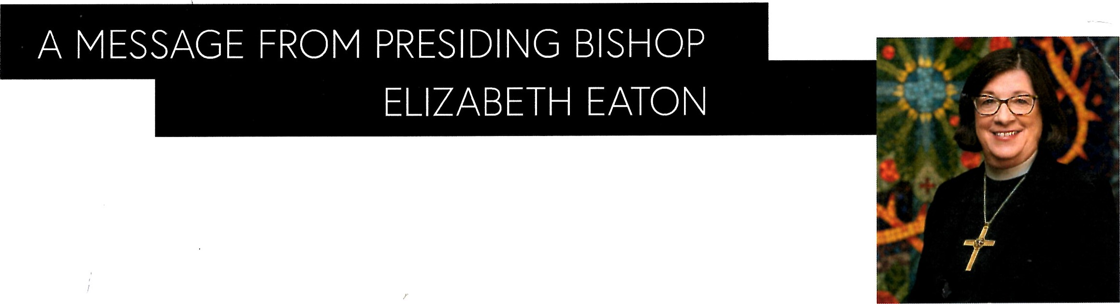
Dear friends in Christ,
Over the past year we have continued to experience changes in the world around us. Even as our church finds ways to adapt to this changing world, we find hope in the unchanging and always present promise of God's love through Jesus Christ. We change and adapt not to conform to the world but because we believe that the gift of God's Son is for the world, and that our congregations and worshiping communities are places to gather and be sent into the world, where we will tell the story of God's love in word and deed.
The ministries of our congregations, our synods and the churchwide organization provide ways for the church to move beyond the boundaries of structures and geography and to share God's love with people in our neighborhoods, our cities, our country and beyond. We engage in this ministry knowing that our church walks by faith, trusting in God's promise in the gospel, and that we exist by and for the proclamation of this gospel word. In John 15:5, Jesus reminds us, "1 am the vine; you are the branches. Those who abide in me and I in them bear much fruit, because apart from me you can do nothing." We are connected by the promise that we do all through Christ and can do nothing apart from him.
God gives the Holy Spirit, who uses gospel proclamation — in preaching and sacraments, in forgiveness and in healing conversations — to create and sustain this faith. Just as we rely on God to sustain our faith, we rely on each other to sustain the ministries that offer God's love to the world.
Through your generosity to each expression
of this church — your congregation, your synod and your churchwide organization — you add to our collective voice proclaiming God's love for all.
I am grateful for your generosity over this last year. My gratitude spreads far beyond your generous financial gifts. You've shared your gifts of time through countless hours of volunteering, serving and accompanying. You've shared the gifts of your voices as we've tried to discover and learn how God is calling us to be the church now and into the future. And, finally, dear church, you have shared the gift of the realness of God's love with the world around you. Be well, dear church, and stand steadfast in the promise of God's love and grace as you take that promise with you into the world.
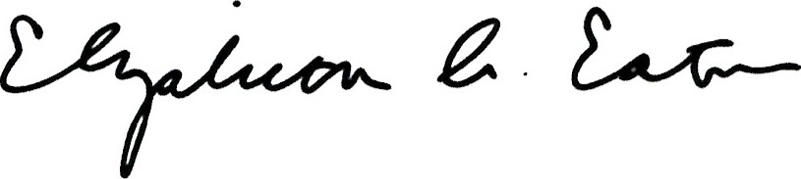
The Rev. Elizabeth A. Eaton
Presiding Bishop
Evangelical Lutheran Church in America
“I am the Vine; you are the branches. Those who abide in me and I in them bear much fruit, because apart from me you can do nothing." —John 15:5

2023 Statistical Report
Congregational statistics and the record of pastoral acts during the year

Baptized Members | 250
Confirmed Membership | 210
Member Activity:
Affirmation of Faith (see below) | 2
Members Transferred In | 0
Baptism: Adults | 0
Baptism: Children (see below) | 2
Baptized Youth Confirmed (see below) | 3
Funerals (see below) | 3
Members Transferred Out (see below) | 5
First Communion (see below) | 7
Weddings (see below) | 1
Avg Christian Education (4k – 9th gr) attendance | 9
Avg Weekly Worship Attendance | 78

Affirmation of Faith: Bill and Ann Willmer

Membership Transfer In:

Baptized (Adults):

Baptized (Children): Hattie Lynn Austin, Jackson Paul Campbell

Confirmed: Jadyn Carlson, Gavin Haw, Rocco Hoffman

Member Funerals: Lea Rundquist, Skip Pendl, Gail Pendl

Friends of our Church Funerals: Bill Schroeder

Members Transferred Out: Carl Evans, Jean Schmidt, Mark and Beth Specht, Zach Stumpf

First Communion: Olivia Baehr, Kylie Brantmeier, Caitlyn Carlson, Ashton Clark, Gavin Clark, Lee Nelson, Miles Schulz

Weddings: Brooke Frelich and Thomas Manderle

Letter from the Council President

Members of Christ the King Lutheran Church-Sherwood,

This letter, putting our 2023 church year into some context has had several edits and changes. Just when I thought I had the appropriate message, events warranted changes to this letter. In the same way, our transition as a church is uneven, with some twists and turns, and sometimes, uncomfortable conversations.

Last October I shared some thoughts with you on our transition, citing several reasons for optimism which I’m happy to say ring just as true today. Thanks to God’s blessings and the work of many of you our church continues to have weekly pastor-led worship services in our beautiful sanctuary and our younger members continue to have their faith nourished through Sunday School or Confirmation class. In addition, our various committees continue to do God’s work addressing needs within our congregation and the community. We enter the new year with solid worship attendance, new Mission and Vision statements to help guide our actions, and sound administrative and finance procedures in place. I continue to have faith that our congregation will find the right fit with our next called pastor. And that together with God guiding us we will advance our mission. To our committee volunteers, church staff, guest pastors, church council, and those of you who have prayed for our church, please accept my sincere thanks and appreciation for all you’ve done and continue to do.

So, now comes the uncomfortable part of this letter. There has been a notable decline in financial giving of almost twenty percent cumulatively in the last six months ending January 2024. Perhaps congregants reduced giving due to the lack of a consistent presence and message from the pastor’s office. It is true that with different pastors our services sometimes can skip a beat from week to week. Unfortunately, the synod has informed me there is no guarantee we will receive an interim pastor and that the call process itself is likely to take longer than we desire. Or perhaps congregants reduced giving under the assumption our church is fine without a called pastor and the related higher expenses. It is true that in the short run our various supply pastors help to maintain worship services and lower operating expenses. However, in the longer run a reliance on supply pastors is not sustainable for such reliance: lacks consistency in voice and decision-making, lacks dependable pastoral care, creates an unsettled environment for visitors who might otherwise look to join our congregation. While the timing of a new called or interim pastor remains uncertain it’s important as a church we stay on solid financial footing. Yes, we are very fortunate to have adequate reserves for now. With that said, if you have changed your giving for reasons related to the transition, please prayerfully consider adjusting your giving.

Looking ahead, I encourage the congregation to be willing to try new things. The reality is that what will work well for our next twenty years here in Sherwood will almost certainly be different than what worked well for our first twenty years. Our transition can be wonderfully positive if we are willing to lean into it. Be bold!

Peace,
Chris Scheuer
Council President, Christ the King Lutheran Church-Sherwood

Committee Updates

Altar Guild
The Altar Guild has continued to care for all things pertaining to the Altar and physical space around the altar in our church. We set up and took down the Communion bread and wine for Sunday and Wednesday services; maintained and changed the color of the paraments and banners according to the ELCA 2023 calendar; kept track and bought, when needed, the wine and bread for communion; organized the Easter Lily and Poinsettias sign-up sheets; kept track of payments, ordered flowers and decorated before Easter and Christmas, along with taking down the decorations after the Spring and Winter events. We also refilled the candles and ordered the oil, as needed, with the help of a couple of dedicated volunteers (Thanks to Mike and Frank). For baptisms we made sure there was water in the baptismal pitcher and the font was ready to use; lit the Paschal Candle before the service and made sure the baptismal certificate, candle and cloth were on the Altar. In 2023, we organized Altar Flower arrangements to be made and delivered on a weekly basis. New white paraments were bought for the altar, along with a new Christmas banner. Looking forward to 2024, we hope to buy some new Christmas decorations and improve the organization of the paraments and banners in the storage closet.
Submitted by Nancy Bastjan, Chairperson of Altar Guild

Buildings and Grounds
The building and grounds committee meets on the second Tuesday of each month at 6:00pm and all are welcome to attend. The committee's regular activities include twice yearly yard clean up, putting up and taking down the Christmas tree / snow fence, setting up tables and chairs for various purposes and addressing issues as they occur. In addition, members of the committee volunteer their time to make sure mowing is maintained over the summer months. I would like to give a big thank you to everyone that helped with the spring and fall clean ups and a huge thank you to the mowing community.
Submitted by Bill Poppe, Chairperson of the Buildings and Grounds

Communications
The communications task force has been active working on options to communicate to the community at large and within our church family. We continue to work on modifying the church website to make it user friendly and sharing information through Facebook. We also would like to continue to provide information to the community by providing flyers, road signs, events, etc. Our hope is to continue to keep open communication within our church and community to let everyone know that our church welcomes people to come as they are without judgement. Suggestions are always welcome. Also remember that word of mouth is a great source of communication and a personal invitation to join our family goes a long way.
Submitted by Connie Simon, Chairperson of Communications

Faith Formation
The Faith Formation Task force has had a very successful start to the school year with great attendance at the VBS program from both attendees and volunteers that helped to make that program a success. For Sunday School we took a different approach to it this year and combined the two classes into one class. One of the benefits that we are seeing is that we are having a lot of interaction between some of our younger students and older students that creates a better learning experience for everyone, including the teachers! The classes are increasing in size where we have between 8 and 12 children in the class together which has been great to see. As always, we are looking for members that have a passion to help the kids learn about all the great things that Jesus and our Church are doing in the world. Finally, I would like to thank all the teacher volunteers that are helping guide our students including Connie Simon, Brittni Nelson, Bill Schulz, Renee Giese, Grace Sullivan, and Jill McElhaney.
Submitted by Bill Schultz, Chairperson of Faith Formation

Memorial Fund
Memorial Committee Update from 2023
The Memorial Committee, along with the Finance Committee and the Church Council, are responsible for the oversight of funds given in memory of a person. In 2023 the Council approved including funds given in honor of a person or event with Memorial funds. To provide more clarity to the process, a form was created to be completed by the donor (with help from Memorial committee members if needed) regarding designation of the donated funds. All church committees have been asked to create a list of items that could be purchased from Memorial funds after approval from the Church Council. This new process also enables Committee members to keep closer track of donations and follow up with the donors with a note of gratitude and information about purchases made with the funds.

In addition to improving the funding process, the Committee has created 2 books. One includes information from past Memorials. The information in this book may not be all inclusive but was gathered from many members who were able to recall gifts we received over the past years. There is also a book for obituary pamphlets we have just begun to create. If you have any of these pamphlets you would like included in the book, please bring them to the church office in c/o Ann Crandall and I will enter them into the book.
Memorial Committee members are: Nancy Bastjan, Sandie Miller, Ann Y Crandall
Submitted by Ann Y Crandall, Chairperson of Memorial Fund

Worship and Music
The music and worship group selects songs for weekly services and works with council to schedule holiday and special event worship.

Once every 2 – 3 months, the group meets via phone/zoom meeting to review the “Sundays and Seasons” website published by Augsburg Fortress (subscription & login required). The website lists weekly scripture readings, liturgical texts, and suggests music that coordinate with the season of the church calendar. The group aims to include songs of various styles, including traditional hymns, contemporary and folk songs, and old favorites to enhance the worship experience. Submitted by Sharon Peters, Chairperson of Music and Worship

Annual Congregational Meeting Minutes
February 26, 2023

- Call to Order – at 10:00am by Council President, Bill Schulz (37adult voting members present)
- Opening Prayer – offered by Pastor Carl
- Constitution- changes first reviewed and approved at the December 18, 2022 meeting were highlighted. Motion was made by Peg Schwalbach to approve and accept constitutional changes; Sandi Miller seconded this motion. All in attendance were in favor.
- 2022 Congregational Meeting of January 27, 2022 – David Miller motioned to accept the minutes of the congregational meeting of 1/27/22; Joe Giese seconded the motion. Motion passed with all supporting.
- MSP Congregational Meeting of December 18, 2022 – Joe Giese motioned to accept the minutes of the congregational MSP meeting of 12/18/22 as they were presented. All in favor and motion passed.
- 2022 Year End Financial Reports – Bev Langford motioned to approve the financial reports of the Capital, General, and Designated Funds. Additional reports included Thrivent investment balance and mortgage information. Second was offered by Joe Giese; no questions or discussions followed. All in favor; motion passed.
- 2021 Financial Audit Report – Peg Schwalbach motioned, and Jill McElhaney seconded to accept the Audit Report of 2021 as present by the team of Brian Helms, Aaron Carlson, and Travis Strebe. No new team members volunteered.
- CtK Representatives-
  - Crossways Camping Ministry – Natalie Poppe
  - Fox Valley Lutheran Homes – Carey & Jo James
  - Synod Assembly – Jerry & Kerry Wilson
Motion to approve above volunteers as representatives of Christ the King to the corresponding ministries as noted above made by Jodi Sullivan; seconded by David Miller
- Council Members – recognition of and appreciation for the outgoing members: Ashley Brantmeier, Bill Schulz, Sandi Miller & Anna Stumo (youth rep). Chris Scheuer, Nate Nelson & Bill Poppe with Madison Poppe as Youth rep have been nominated to serve as new council members. Motion made to approve and elect all the above made by Joe Giese; seconded by David Miller. All in favor; motion passed.
- Pastor offered insight into the next steps of developing a mission for CtK. He states cottage meetings to discuss the life of the congregation and how it impacts us will begin in approximately 6 weeks. Later in Spring, activities will be held to further develop the mission and values statements. Pastor encourages all to participate.
- New Business – no new business was brought forward.
- Closing Prayer – Pastor led attendees in reciting the Lord’s Prayer.
- Motion to adjourn – Bev Langford motioned; Kim Schulz seconded – all in favor!

Congregation Financial Meeting Minutes
December 10, 2023
Call to Order at: 10:05 AM
Council Members Presenting: Chris Scheuer, Jodi Sullivan.
Congregation Members Present: 28-members present.
Opening Prayer: Chris Scheuer.
Review of 2023 – Biggest News for the Congregation
Chris reviewed 2023 from the perspective of biggest news for the church, suggesting it was the adoption of new Mission and Vision Statements. He went to highlight many of the current ministries and activities at CtK-Sherwood, showing how the congregation is already putting our mission into practice, not only within our church but importantly out into the Sherwood area.

Finance Update and 2024 Spending Plans
Jodi provided a review of the purpose of and current financial situation for the church’s General and Capital Funds. She then reviewed the process by which 2024 spending plans for both funds were established, provided specific spending estimates and justification for those estimates.

2024 Proposed Spending Plans
$125,201.00 General Fund
$19,512.00 Capital Fund
$144,713.00 Annual Planned Spending (General & Capital Funds excluding Mission of the Month)
$12,059.00 Monthly Giving Required to Match Planned Spending

Following Jodi’s presentation, a motion was made to approve the 2024 spending plans and the plans were unanimously approved.

Congregation Vote | Moved by | Seconded by | Vote
Motion to approve 2024 Spending Plans: | Bill Schultz | Tim Hemaurer | 28 - 0
Approval of Constitution Bylaw to be sought in 2024.
Chris notified the congregation that a constitution bylaw will be voted on at the 2024 Annual meeting, to be held Sunday February 25th after the 9am service. The bylaw is to place into the church constitution the recently adopted mission and vision statements.

Proposed Constitution Bylaw
C4.05.01: Add the mission and vision statements as adopted by the Congregation on 10/15/23.

Mission: To be a Christ-centered, welcoming congregation, joyfully sharing the good news of God’s love and grace with others.

Vision: A community where the all-encompassing love of Jesus flourishes.

Thoughts on 2024
Chris shared some things the congregation should be mindful of for 2024.
- The work of our church, our mission goes on whether we are being led in worship by a supply pastor, an interim pastor, or a called pastor.
- The transition process has begun, with the Missionary Site Profile (MSP) team already working on writing this important document. Our church is in steady contact with the synod as we look to find an interim pastor as soon as possible.
- Chris highlighted that the spending plans approved today could ultimately prove modestly too low should an interim pastor require somewhat more than the expected half-time work the spending plans assume or if an interim pastor is found sooner than expected July 1st starting date.
- Chris stated that such added expense above the 2024 spending plan it would be good news for our congregation, money well spent, affordable and sustainable.
- Chris closed his comments by highlighting his optimism and excitement for the future of CtK-Sherwood and his hopes his views are shared by all in the congregation.

After asking for but receiving no questions or comments from the congregation Chris called for a motion to adjourn which was unanimously approved.

Motion to adjourn:
Congregation Vote | Moved by | Seconded by | Vote
Motion to adjourn: | David Miller | Frank Dominczak | 28 - 0

Summation of Business Votes:
Congregation Votes | Motion | Vote
Motion to Approve 2024 Spending Plans: | Bill Schultz | 28 - 0
Motion to adjourn: | David Miller | 28 - 0

Edited w/ added content by: Chris Scheuer (original notes taken by Grace Sullivan)

Christ the King Lutheran Church-Sherwood
Mortgage Report
Year End December 31, 2023
********************************************************************
Mortgage Analysis
 | Original Mortgage: |  |  |  |  | $ 306,000.00
 | Mortgage Balance as of December 31, 2023 |  |  |  |  | $ 188,232.58
 | Interest Paid in 2023 |  |  | $ 9,079.66
 | Principal Paid in 2023 |  |  | 10,432.34
 | Total Mortgage Payments |  |  | $ 19,512.00
The note is amortized over 20 years. - Maturity Date 08/01/2037 (Refinanced the mortgage in Aug 2017)
Interest Rate is at 5.4%
The mortgage holder for the church is Thrivent Financial for Lutherans.
********************************************************************

