**Fifth Sunday after Epiphany**

**FEBRUARY 4, 2024**



**CHRIST THE KING LUTHERAN CHURCH – SHERWOOD**

**Sunday, February 4, 2024 – 9 am**

**Wednesday, February 7, 2024 – 6:30 pm**

**CONFESSION AND FORGIVENESS**

P: Blessed be the holy Trinity, ☩ one God,

creator of darkness and light,

word of truth,

wind sweeping over the waters.

**C: Amen.**

P: Let us confess our sin in the presence of God and of one another.

*Silence is kept for reflection.*

P: God, our rock and refuge,

**C: we pour out our hearts before you.**

**We have known you but have not always loved you.**

**We have wounded one another**

**and sinned against you.**

**We have not always recognized the Holy Spirit**

**dwelling in each of us.**

**Remember your covenant.**

**Renew your creation.**

**Restore us,**

**that we might proclaim your good news to all.**

**Amen.**

P: The voice of the Lord is upon the waters.

God has spoken:

The time of grace is now.

In Jesus, the reign of God has come near.

By the authority of ☩ Jesus Christ,

your sins are forgiven.

You are God’s beloved.

**C: Amen.**

**PRAYER OF THE DAY**

P: Everlasting God, you give strength to the weak and power to the faint. Make us agents of your healing and wholeness, that your good news may be made known to the ends of your creation, through Jesus Christ, our Savior and Lord.

**C: Amen.**

**GATHERING HYMN:** Praise to the Lord, the Almighty; ELW 858

**READING: 1 Corinthians 9:16-23**

R:  16If I proclaim the gospel, this gives me no ground for boasting, for an obligation is laid on me, and woe to me if I do not proclaim the gospel! 17For if I do this of my own will, I have a reward; but if not of my own will, I am entrusted with a commission. 18What then is my reward? Just this: that in my proclamation I may make the gospel free of charge, so as not to make full use of my rights in the gospel.  
 19For though I am free with respect to all, I have made myself a slave to all, so that I might win more of them. 20To the Jews I became as a Jew, in order to win Jews. To those under the law I became as one under the law (though I myself am not under the law) so that I might win those under the law. 21To those outside the law I became as one outside the law (though I am not free from God’s law but am under Christ’s law) so that I might win those outside the law. 22To the weak I became weak, so that I might win the weak. I have become all things to all people, that I might by all means save some. 23I do it all for the sake of the gospel, so that I may share in its blessings.

R**:** The Word of the Lord

**C: Thanks be to God**

P: The Holy Gospel According to Mark

**C: Glory to you, O Lord**

**GOSPEL: Mark 1:29-39**

P:29As soon as [Jesus and the disciples] left the synagogue, they entered the house of Simon and Andrew, with James and John. 30Now Simon’s mother-in-law was in bed with a fever, and they told him about her at once. 31He came and took her by the hand and lifted her up. Then the fever left her, and she began to serve them.  
 32That evening, at sunset, they brought to him all who were sick or possessed with demons. 33And the whole city was gathered around the door. 34And he cured many who were sick with various diseases, and cast out many demons; and he would not permit the demons to speak, because they knew him.  
 35In the morning, while it was still very dark, he got up and went out to a deserted place, and there he prayed. 36And Simon and his companions hunted for him. 37When they found him, they said to him, “Everyone is searching for you.” 38He answered, “Let us go on to the neighboring towns, so that I may proclaim the message there also; for that is what I came out to do.” 39And he went throughout Galilee, proclaiming the message in their synagogues and casting out demons.

P: The Gospel of the Lord

**C: Praise to you, O Christ**

**CHILDREN’S SERMON**

**SERMON**

**HYMN OF THE DAY:** Beauty for Brokenness; W&P 17

**APOSTLES’ CREED**

**I believe in God, the Father almighty, creator of heaven and earth.**

**I believe in Jesus Christ, God’s only Son, our Lord,  
who was conceived by the Holy Spirit, born of the virgin Mary,  
suffered under Pontius Pilate, was crucified, died, and was buried; he descended to the dead.\***

**On the third day he rose again;  
he ascended into heaven, he is seated at the right hand of the**

**Father, and he will come to judge the living and the dead.**

**I believe in the Holy Spirit, the holy catholic church,  
the communion of saints, the forgiveness of sins,  
the resurrection of the body, and the life everlasting. Amen.**

**PRAYER SONG:** Lord, Listen to your Children Praying; ELW 752

**PRAYERS OF INTERCESSION**

P: God of grace,

**C: receive our prayer**

**SHARING OF THE PEACE**

**THE OFFERING PRAYER**

P: Blessed are you, Holy One,

for all good things come from you.

In bread and cup you open heaven to us.

Meet us at this table,

that we receive what we seek

and follow your Son, Jesus,

in whose name we pray.

**C: Amen.**

**THE WORDS OF INSTITUTION**

**THE LORD’S PRAYER**

**Our Father, who art in heaven, hallowed be thy name,  
thy kingdom come, thy will be done, on earth as it is in heaven.  
Give us this day our daily bread; and forgive us our trespasses,  
as we forgive those who trespass against us; and lead us not into temptation, but deliver us from evil. For thine is the kingdom, and the power, and the glory forever and ever. Amen.**

**HOLY COMMUNION – (Gluten Free Bread)**

**COMMUNION HYMN:** On Eagle’s Wings; ELW 787

**COMMUNION BLESSING**

**POST-COMMUNION PRAYER**P: Giver of every gift,

Christ’s body is our food, and we are Christ’s body.

Raise us to life by your power

for the benefit of all and to your glory,

now and forever.

**C: Amen.**

**ANNOUNCEMENTS**

**SENDING HYMN:** Precious Lord, Take My Hand; ELW 773

**BLESSING**

P: God who names you,

Christ who claims you,

and the Holy Spirit who dwells in you,

☩ bless you and remain with you always.

**C: Amen.**

**DISMISSAL**

P: Go in peace. You are God’s beloved.

**C: Thanks be to God.**

**ELW 858**



**W&P 17**

**Beauty for Brokenness**

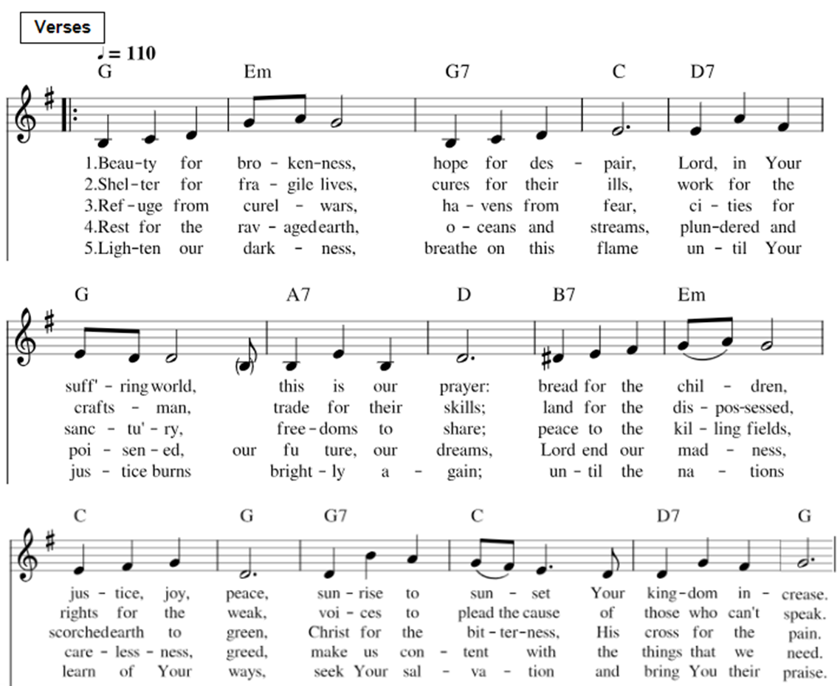

**ELW 787**



**ELW 773**

**ANNOUNCEMENTS**

**Voices of Peace** will be performing for us on Sunday, February 18. Voices is a Gospel singing group from Potter, WI. They sing and preach the whole hour. This would be a wonderful time to invite a friend to join us in worship. There will be a free will offering at the end of the service.

**Church Council Opportunity**

At the February 25th Congregation Annual Meeting your council will be looking for three church members to join council as three member terms come to an end. Whether you would be serving for the first-time or you’ve served in the past, this is a terrific way to share your time and talents during this period of church transition. Please give this opportunity thought and prayerful consideration. If interested or have specific questions, please reach out to Chris Scheuer at [**cscheuer900@gmail.com**](mailto:cscheuer900@gmail.com)**.**

**Flowers are back!!** We have made arrangements with Schroth Brillion Floral for bi-weekly floral arrangements. The flower chart is up on the wall in the hallway, and we hope everyone takes advantage of signing up for a date to adorn the altar. Your flowers will remain on the altar for 2 Sundays and 2 Wednesdays. The cost will still be $40, and we ask that you place your payment in an envelope (located by the flower chart) with your name and payment type (cash or check) indicated on the envelope.

**Help for the Homeless Hygiene Drive** - Your support makes a HUGE difference in the lives of the recipients and the organizations that will distribute the products. This drive is sponsored by The Family Radio, Calumet County Salvation Army, FOX11 and other companies in our area.

Simple things such as deodorant, shampoo, toothpaste and a new toothbrush restore hope and self-confidence to the people who use them. These items also relieve the financial burden of crisis agencies in Calumet County who hand them out. It's a win-win for all! Volunteers will be distributing donation boxes and printed posters next week.

The drive runs from February 11 through March 8. Donation boxes will be picked up the morning of Friday March 8 by Hygiene Drive volunteers.

**Most Needed Items –**

**Bathroom Tissue  
Cleaning Supplies  
Dental Care  
Deodorant  
Diapers/Baby Care  
Face/Bath Soap  
Feminine Care  
Hair Care  
Laundry Detergent  
Paper Towels  
Razors  
Trash Bags**

Once again, we truly appreciate your support for this project which helps the homeless and those in need in Calumet County. If you have any questions, please give John at the Salvation Army or myself a call or email.

Donna Krippner

920-203-8038

Volunteer at St. Vincent de Paul - Hilbert

**Donations remain in the community where collected! Donate here, Festival Foods or Walgreens.  
Details at thefamily.net or 800-236-936**

**UPCOMING VOLUNTEERS**

**Sundays**

|  |  |
| --- | --- |
| **February 4** | **February 11** |
| Worship Host: Jodi Sullivan | Worship Host: Nate Nelson |
| Reader: Olivia Baehr | Reader: Connie Simon |
| Communion: Peg Schwalbach, Jodi Sullivan | Communion: Ann Crandall, Sandie Miller |
| Projection: Avery Carlson | Projection: Deb Dominczak |
| Counters: Sharon Peters, Bev Langford | Counters: Lees, Debby Voss |
| Kitchen: Natalie Poppe, Madison Baehr, Beth Hopfensberger | Kitchen: Sandie Miller, Mary Alice Lee, Iryna Ratner |
| Ushers: Bill Willmer, Bill Poppe | Ushers: Deb Dominczak, David Miller |
| Altar Care: Deb Dominczak | Altar Care: Deb Dominczak |

**Wednesdays**

|  |  |
| --- | --- |
| **February 7** | **February 14** |
| Reader: Tony Wieczorek | Reader: Chris Scheuer |
| Communion: Carter Strebe | Communion: Kristin Scheuer |
| Wednesday Altar Care: Jolene Weber | Wednesday Altar Care: Nancy Bastjan |

**Christ The King Lutheran Church - Sherwood**

**Guest Pastor:** Pastor Roy Rogers

**Administrative Assistant:** Heather Plainse

**Email:** [admin@ctklutheransherwood.org](mailto:admin@ctklutheransherwood.org)

**Phone:** 920-989-5070

**Financial Administrator:** Kim Allen

**Email:** [finance@ctklutheransherwood.org](mailto:finance@ctklutheransherwood.org)

**Office Hours:** Monday – Thursday

9 am – 1 pm

**Worship Times:**

Sundays @ 9am

Wednesdays @ 6:30 pm

**Check us out online:**

[**https://www.facebook.com/ChristheKingSherwood**](https://www.facebook.com/ChristheKingSherwood)

[**https://ctklutheransherwood.org**](https://ctklutheransherwood.org)

**Our Mission:** To be a Christ-centered, welcoming congregation, joyfully sharing the good news of God's love and grace with others.

**Our Vision:** A community where the all-encompassing love of Jesus flourishes.